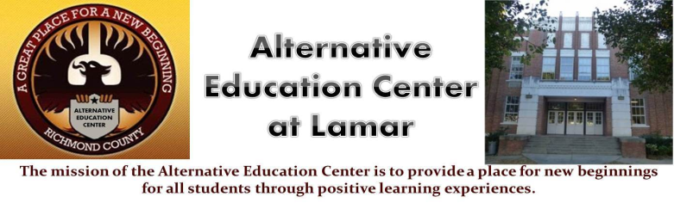**Alternative Education Center**

**Charles Givens- Principal**

Chauncey Scott – Asst. Principal

work Phone -706-796-4965 970 Baker Ave. Augusta, GA 30904



Dear Parent or Guardian,

I want to take this opportunity to express my excitement about working with your child this semester . The main goal of my course is to help you child master the Georgia Performance Standards. Over the course of this year, we will

* Bridge essential understanding about the past to contemporary events.
* Assist students in understanding the nature of historical inquiry and the role of primary and secondary sources.
* Encourage the consideration of multiple perspectives on events.
* Engage students in speculation about the known and unknown motives and actions of historic figures.
* Integrate the strands of Social Studies.

**CLASSROOM GOAL**

I believe all students have the ability to shape their own lives and society in positive ways. My goal this year is to have all students recognize their power and use that power to improve themselves and their communities. We will use world history to inform students’ vision and to increase their ability to make that vision a reality. In order to achieve this goal, we will need supplies, organization and procedures. These are outlined below.

**NECESSARY SUPPLIES**

A notebook ( any type; must last for the duration of class)

loose leaf paper

pencil or pen

Project Supplies

**Class RULES**

All *AES*  rules will apply in our classroom. Students are also asked to

* Show respect (to other people, the environment and yourself)
* Do your best (which requires believing in yourself, being prepared and always trying as hard as you can)

**GRADES**

* Syllabus/ Notebook – 25%
* Classwork/Quizzes – 25%
* Projects – 25%
* Tests 25%

A Syllabus will be given to each student that includes the monthly tasks and projects. The first one is provided. Please check off each task as they are completed..

If you ever have any comments, questions or concerns, I am available for phone calls and meetings (by appointment please) each day before and after school. To schedule a meeting, you may contact me via[*GrierLa@rck12.or*](mailto:GrierLa@rck12.or)*g or 7067964965*

I am excited about working with your child. I welcome questions or comments, and am looking forward to a great year!

Sincerely,

*L. Grier*

*Social Studies*  Teacher